Reviewing your Transfer Credits

**How to access your transfer evaluation:**

Students can access their transfer credit evaluation through the [Banner Information System](https://banner.spu.edu).

After logging in, select the “Student Menu,” and then from the “Academic Records Menu” select “UG Degree Check.” ***Beginning April 1, evaluations are available within ten days of admission for fall admits. If admitted in winter, spring, or summer quarters, evaluations will be available within ten days of admission, but not before the 10th day of the previous quarter.***You will receive an email notification when your transfer credit evaluation is complete.

NOTE: For assistance with the log-in process, including locating your username or password, please refer to [spu.edu/findmyid](http://spu.edu/findmyid).

Step One:

Step Two:

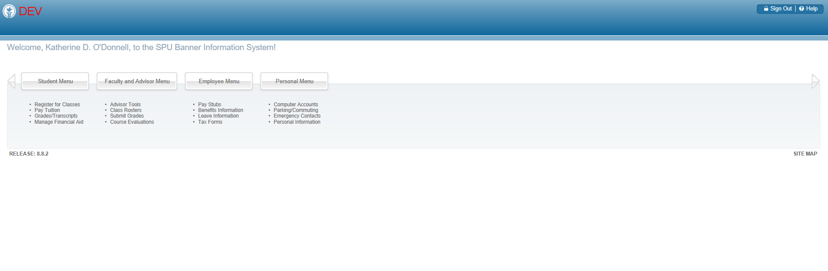

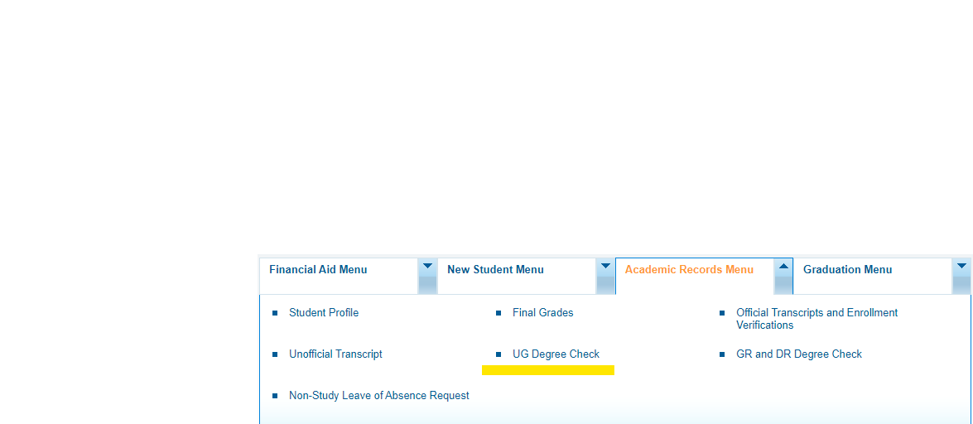

**How to read your transfer evaluation:**

Courses that fulfill specific General Education Requirements appear on the first page of your UG Degree Check, under the “Graduation Requirements Audit” tab. For a full list of transferred courses and their equivalencies, scroll to the bottom of the page and review the “Transfer Courses Taken and Their SPU Equivalent.”

**Within the “Transfer Courses” Section:**

* Transfer institution(s), dates of attendance, and total credits accepted from the institution(s) will be listed first.
* Below the list of transfer institutions will be two columns. Transfer courses will be listed on the left and the SPU transfer equivalent course or code will be shown to the right.
* Common equivalencies (other than those directly equivalent to an SPU course) may include:

|  |  |
| --- | --- |
| SPU LDEL or SPU UDEL, Transfer LD or UD Elective | The course is not equivalent to a course SPU offers, but it is transferrable and will count towards the minimum 180 credits required for graduation. |
| SPGE Lower or Upper Division WKA, H, QR, AS, FS, SS | This course is not equivalent to a course SPU offers, but it will meet a requirement in the Exploratory Curriculum. The corresponding section will be filled in the Graduation Requirements Audit above. |
| Lower or Upper Division WE | This course is not equivalent to a course SPU offers, but *may* fulfill your Ways of Engaging Requirement in Exploratory Curriculum. |
| *Syllabus Required | The faculty reviewer requires a syllabus in order to determine equivalency. |
| *Under Department Review | We have sent the course information to the faculty reviewer and are awaiting a response. Continue to monitor your UG Degree Check. |

NOTE: 1 semester credit equals 1.5 quarter credits. For example, a 3-credit semester course will transfer as 4.5 quarter credits. 4 and 4.5 credit transfer courses are considered sufficient to meet Common and Exploratory Requirements.

***Continued on next page →***

**Important Notes**

* **Have you taken courses after the dates of attendance listed?**

You will need to have an updated and official transcript sent to SPU. Please note that in-progress (ungraded) courses will not show as a part of your evaluation.

* **Do you have coursework from a school not listed?**

If there is a school you attended that is not listed, that means we do not have an official transcript for you from that school. You will need to request an official transcript be sent to SPU.

* **Are you completing an approved Associates Degree from a Washington (DTA), Oregon (AA/OT and AS/OT-B, or California (IGETC) community college?**

If so, please send us an updated official transcript, as the approved Associates Degree will exempt you from many of the requirements in the common and exploratory curriculum. Approved Associate Degrees can be located in the [Admissions section](https://spu.edu/catalog/undergraduate/20201/admissions/acceptance-two-year-degree) of the online undergraduate catalog (UG Catalog Home > Admissions > Acceptance of Two-Year Degrees).

* **Have you completed three or more years of the same foreign language in high school with a C or better in your final quarter or semester, but your language requirement is still incomplete?**

Please be sure to have an official high school transcript sent to SPU.

* **Are you interested in seeing how your courses may count towards your intended major or minor?**

If have you have already declared a major or minor, you can simply click the blue “admitted” link next to your major at the top of the page. Otherwise, click the Major/Minor Requirements button (highlighted below) on the top of the Degree Check: Graduation Requirements Audit page. Select term, college, and major/minor for a listing of the major or minor requirements.

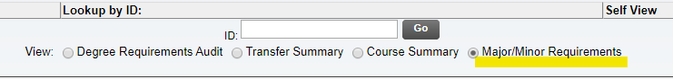

**Next steps for your transfer evaluation:**

1. Ensure SPU receives final, official transcripts for all college-level coursework.
2. If you are a new student ready to enroll at SPU, your next steps will be to submit your Advanced Payment and sign up for New Student Advising (NSA) through the [Seattle Pacific portal](https://admissions.spu.edu/account/login?r=https%3a%2f%2fadmissions.spu.edu%2fportal%2fug_status). Additional information on NSA, including links to sign up, can be found on the [NSA website](https://www.spu.edu/nsa).
3. If you want more information on understanding and using your Undergraduate (UG) Degree Check, you can complete the “New Student Advising Survey” through the [Seattle Pacific portal](https://admissions.spu.edu/account/login?r=https%3a%2f%2fadmissions.spu.edu%2fportal%2fug_status). This required tutorial prepares new students for participation in New Student Advising and Registration. *Note: This tutorial is available March 1 for fall quarter admits and available upon admission for students admitted in all other terms.*
4. Have questions about your transfer evaluation? Please connect with your Undergraduate Academic Counselor. UA Counselors are assigned alphabetically and are listed on the [Undergraduate Academic Counseling website](https://spu.edu/administration/academic-counseling/advising/counselors/drop-in-advising).